

2011 – 2012
LASER, LASER RADIAL AND LASER 4.7
NSW AND ACT METROPOLITAN CHAMPIONSHIP

25th and 26th February 2012
Bayview Yacht Racing Association
NOTICE OF RACE

The Organising Authority is the NSW & ACT District Laser Association in association with Bayview Yacht Racing Association under the authority of Yachting NSW

- RULES
The Championship will be governed by the 2009-2012 Racing Rules of Sailing, the Prescriptions and Special Regulations of Yachting Australia, the rules and by-laws of the International Laser Class Association, (except as any of these are changed by the Sailing Instructions) and by the Sailing Instructions.
- ELIGIBILITY
All competitors shall be financial members of a District of the ILCA and of a Yacht or Sailing Club affiliated with a National Authority. Eligibility for age groups shall be the age on 25th February 2012.
- ENTRIES
  - Entries on the attached entry form, or on-line at www.laser.asn.au, together with the entry fee should reach the Regatta Secretary by the close of official entries at 2359 hours on 18th February 2012.
  - Late entries may be accepted up until 1130 hours Saturday 25th February 2012.
- FEES
Entry fee schedule:
- $60.00 per boat
- $70.00 after close of official entries
- CATEGORIES AND DIVISIONS
  - Categories are as described in the Entry Form.
  - There will be a separate start for each of Standard, Radial and 4.7 Divisions, providing there is a minimum of five entries to the Division. Division starts may be further split depending on the number of competitors.
- SCHEDULE
  - Championship Schedule:
Day | Date | Event | Time
Sat | 25 Feb | Registration | 0930 to 1130 hrs
Sat | 25 Feb | Briefing | 1130 hrs
Sat | 25 Feb | Racing | First Warning Signal 1330 hrs. Subsequent starts shall be made ASAP after the preceding race
Sun | 26 Feb | Racing | First Warning Signal 1100 hrs. Subsequent starts shall be made ASAP after the preceding race
  - A maximum of six races are scheduled for the Championship.
  - No Warning Signal shall be hoisted after 1530 hrs on the Sunday 25th February 2012.
- MEASUREMENT
Each skipper shall be responsible for ensuring that their yacht and equipment comply with the ILCA rules and the Yachting Australia Special Regulations. The Organising Authority reserves the right to inspect any yacht at any time during the Regatta.
- SAILING INSTRUCTIONS
The Sailing Instructions should be available on the NSW and ACT Laser Association website http://www.laser.asn.au/ and will be available at registration.
- REGATTA SITE
The Championship venue is shown in Illustration A. Bayview Yacht Racing Association is located at
1842 Pittwater Rd, Bayview NSW
http://www.byra.org.au/index.php

- RACING AREA
The racing area will be the waters of Pittwater to a northern limit of Lion Island as shown in Illustration A.
- COURSES
The courses shall be inner and outer loop trapezoids as will be described in the Sailing Instructions.
- SCORING
  - Six races are scheduled, of which three shall be completed to constitute a series. When four or more races are completed, the worst will be discarded.
  - All Divisions will be scored separately.
- PRIZES
Prizes will be awarded to the winners of each Division. Other prizes may also be awarded at the discretion of the Organising Authority.
- INSURANCE
Each participating boat shall be insured with a valid third party liability insurance with cover of not less than $AUS 10,000,000.
- DISCLAIMER
All those taking part in this Regatta do so at their own risk and responsibility. Attention is drawn to RRS Fundamental Rule 4 Decision to Race “A boat is solely responsible for deciding whether or not to start or to continue racing”. Yachting NSW, the NSW and ACT District Laser Association, Gosford Sailing Club, their officers, and the Regatta officials, volunteers and sponsors do not accept any liability for the material damage or personal injury or death sustained in conjunction with or prior, during or after the regatta. Gosford Sailing Club and/or the NSW and ACT District Laser Association reserve the right to refuse an entry.
NSW & ACT DISTRICT LASER ASSOCIATION
2011-2012 METROPOLITAN CHAMPIONSHIP
25th and 26th February 2012
ENTRY FORM
(Please print clearly in Block Letters)
Sail No. ________________________________________
Skipper ____________________________________
Club ___________________________________________
Skipper’s Age _______ (For Championship. See NoR 2)
Divisions / Categories (please circle applicable category):

STANDARD | RADIAL | 4.7
Open | Open | Open
U21 | U19
Apprentice | Apprentice
Master | Master
Grand Master | Grand Master
Great Grand Master | Great Grand Master
 | Women

Address ________________________________________
_______________________________________________
Phone __________________ (w)___________________(h)
Mob __________________email _____________________
I agree to be bound by The Racing Rules of Sailing and all other rules that govern this event
Signed ______________________________Date______________
For sailors under 18 on 25th February 2012, parent of guardian to
sign below:
Parent or Guardian ____________________Date _____________
Please return, with appropriate fee by 2359hr 18th February 2012 to:
Regatta Secretary NSW & ACT District Laser Association
PO Box K315
Haymarket, Sydney NSW 2000

Entry Fees:
$60.00
Late entry fee payable after close of official entries:
$70.00
To pay Entry Fee by credit card
VISA Mastercard Bankcard
Card No __ __ __ __ __ __ __ __ __ __ __ __ __ __ __ __
Expiry date __ __/ __ __ Amount $_____________
Name of Card Holder ______________________________
Card Holder signature_______________________________
If paying by Cheque, please make cheque payable to:
’NSW & ACT District Laser Association’
Entries can be made on line, go to www.laser.asn.au and follow the link for on-line entry and payment.

Illustration A Regatta Site & Racing Area
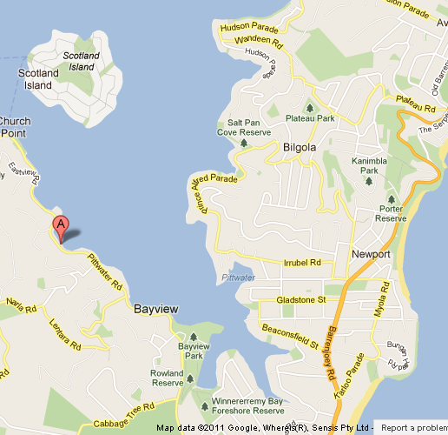

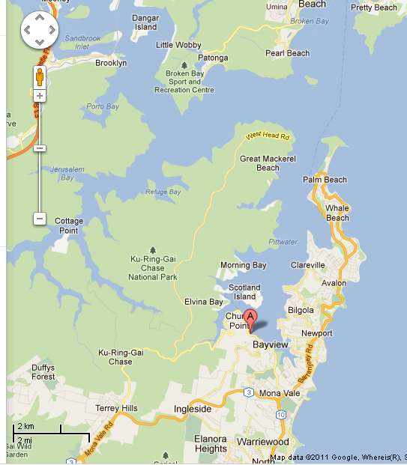
BYRA
General Racing Area

2011 - 2012
LASER, LASER RADIAL AND LASER 4.7
NSW AND ACT METROPOLITAN CHAMPIONSHIP

NOTICE OF RACE

25th and 26th February 2012

Hosted by

Bayview Yacht Racing Association

Organising Authority

NSW and ACT District Laser Association
in association with
Bayview Yacht Racing Association
under the authority of
Yachting NSW

