AUSTRALIAN LASER CLASS ASSOCIATION



NOTICE OF RACE

2011 AUSTRALIAN MASTERS CHAMPIONSHIPS

PORT STEPHENS SAILING & AQUATIC CLUB INC

FEBRUARY 11 – 14, 2011

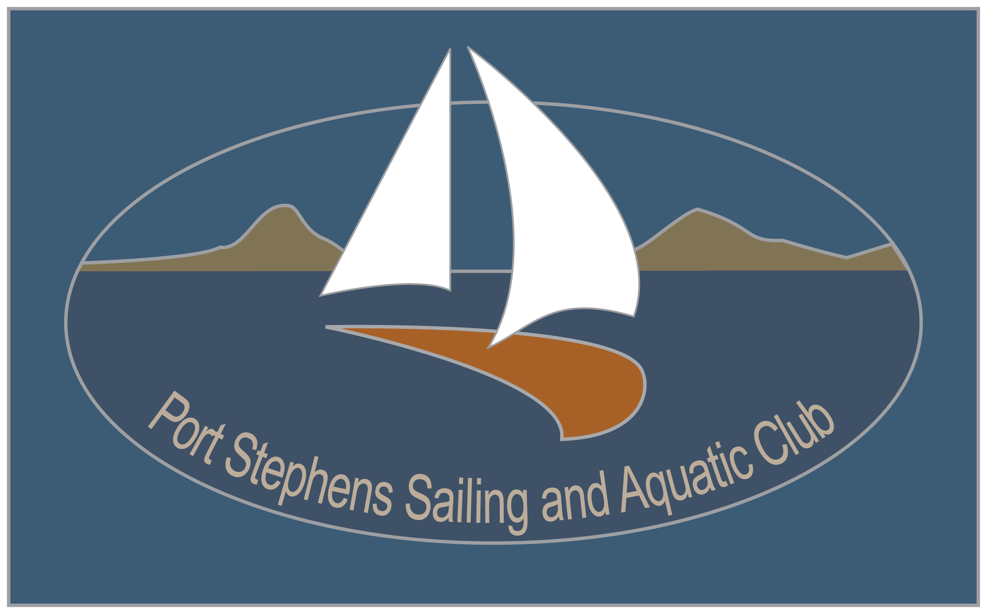
The Organising Authority for this regatta is Port Stephens Sailing & Aquatic Club Inc (PSS & AC) in conjunction with the NSW and ACT District Laser Association Inc. and the Australian Laser Class Association Inc. (ALCA). The Organising Authority invites entries for the 2011 Australian Laser Masters Championships to be conducted on Port Stephens, NSW from the 11 – 14 February 2011.

- RULES:
- The Championships will be governed by the rules as defined in the Racing Rules of Sailing 2009-2012, the Rules and By-laws of the International Laser Class Association (except as these may be changed by the Sailing Instructions) and by the Sailing Instructions.
- Yachting Australia Special Regulations Part 2 Off the Beach Boats will apply. It will be the responsibility of all competitors to ensure that personal flotation devices comply with a standard equivalent to those listed in Regulation 5.01 Personal Flotation Devices.
- Sails shall have the full sail number in accordance with the Class Rules and RRS.

- ADVERTISING
The Organising Authority reserves the right to refuse advertising by any boat, if it is considered offensive to public taste or if it contravenes the laws of the governments of NSW or Australia.
Competitors may be required to display event sponsor’s names(s)/logo(s) and affix bow numbers to boats. If required, the Organising Authority will supply these items and they shall be affixed as prescribed in the Sailing Instructions. Sponsor’s bibs or similar may also be supplied.

- ELIGIBILITY
- All competitors shall be financial members of a District of the International Laser Class Association (ILCA) and of a yacht or sailing club affiliated with ISAF.
- The regatta is open to all Laser Masters sailors who are at least 35 years of age at 11 February 2011. Eligibility for age divisions shall be determined by the competitor’s age at 11 February 2011.
- All competitors shall have adequate and current Public Liability insurance covering the use of the boat while racing (See Clause 15).

4. ENTRIES
- Entries may be lodged online via the Regatta web site at http://www.laser.asn.au or by mail to NSW and ACT District Laser Association at PO Box K315, Haymarket NSW 2000 before 1700hrs (ESDST) on 1st February 2011 accompanied by the required entry fee (see Clause 5).
- Late entries will be accepted via the Regatta web site up to 1300 hours 8th February 2011 accompanied by the required Entry Fee plus the Late Fee.
- At the discretion of the Organising Authority, late entries may be accepted (in person only) at the Regatta Office, PSS&AC between 1200 hrs and 1700 hrs on 10th February and 0900 and 1100 hours on 11th February 2011.
- All boats shall complete registration with the Organising Authority at the times specified in
Clause 7.
- The Organising Authority will not refund Entry or Late Fees in any circumstances. Entries will not be valid until applicable payment has been received by the Organising Authority.
5. FEES
- The Entry Fee for all classes and divisions, which includes one ticket to the welcome cocktail party on February 11 and one ticket to the regatta dinner on February 13, is $125.00.
- The late entry fee is an additional $50.00 with no exceptions.

6. CLASSES, DIVISIONS AND RACING FORMAT
- Racing will be conducted in up to three (3) Classes as follows:
  - Laser Standard
  - Laser Radial and
  - Laser 4.7
- Divisions will include:
  - Apprentice Masters (35 – 44 years)
  - Masters (45 – 54 years)
  - Grand Masters (55 – 64 years)
  - Great Grand Masters (65 years plus)
provided a minimum of 5 entries are received for that Division.
c) Men and women competitors from the same age division will race together, but there will also be separate Women’s prizes (cubes) in each age division should sufficient entries be received as per ILCA guidelines.
- Fleets within each Class shall be that combination of boats as nominated by the Organising Authority.
- Depending on interest received, and a formal decision from ILCA, it is the Organising Authority’s intention to offer racing to Great Grand Masters in each of the Standard, Radial and 4.7 Classes.

7. PROGRAM
- Schedule of Events:

Thursday 10th February 2011 Registration 1200 – 1700

Friday 11th February 2011 Registration 0900 – 1100
Competitors’ meeting 1100
Races 1, 2 1st Warning Signal 1330
Welcome cocktail party 1830 – 2000

Saturday 12th February 2011 Races 3, 4, 5 1st Warning Signal 1230

Sunday 13th February 2011 Races 6, 7, 8 1st Warning Signal 1230
Regatta dinner 1930

Monday 14th February 2011 Races 9,10 1st Warning Signal 1130
Presentation 1600 approx

- The Race Committee may elect to change the start time of the following day’s racing based on weather forecasts and the various fleet requirements. A notice advising of any such change will be posted no later than 1830 on the preceding race day.
- No Warning Signal will be displayed after 1430 hrs on the last day of racing.

8. MEASUREMENT
- It is each competitor’s responsibility to ensure that his/her boat and equipment complies with the ILCA rules and the Yachting Australia Special Regulations.
- The Organising Authority may inspect any boat at any time during the regatta. Any competitor’s boat which fails an inspection may be disqualified from all races prior to such inspection.
- For the duration of the regatta, each competitor shall use only one hull, sail, mast, boom,
centreboard and rudder. Such equipment may only be replaced as allowed by and in accordance with the Sailing Instructions.
- The boats of female competitors shall display a red diamond on their sail in accordance with ILCA Women’s Policy.

9. SAILING INSTRUCTIONS
Sailing Instructions will be available when registering at the Regatta Office at PSS&AC and may be available earlier on the Regatta website at http://www.laser.asn.au

10. REGATTA SITE AND RACING AREA
The regatta site shall be Port Stephens Sailing & Aquatic Club at Soldiers Point, Port Stephens NSW and the racing area shall be on the open waters of Port Stephens in the vicinity of the club.

11. COURSES
The courses shall be trapezoidal type with inner and outer loops, as described in the Sailing Instructions.

12. SCORING
- Except as modified by the Sailing Instructions, all Age Division points will be awarded based on the placing of competitors in their age division in each race.
- 10 races are scheduled, of which 4 shall be completed to constitute a series. When 6 or more races are completed a boat’s worst score will be discarded. If 9 races are completed a boat’s two worst scores will be discarded.

13. PRIZES
- Laser Class cubes and other prizes shall be awarded in accordance with ILCA guidelines; therefore the number of prizes allocated in any division shall depend on the number of entries. A minimum of five (5) entries is required to constitute a Division.
- Laser class cubes and other prizes will be awarded regardless of the competitor’s nationality or country of residence.
- Other prizes may be awarded at the discretion of the Organising Authority.

14. DISCLAIMER OF LIABILITY
Competitors participate in the regatta entirely at their own risk – see RRS 4, Decision to Race. None of the Organising Authority, the NSW & ACT District Laser Association, ALCA or PSS & AC will accept any liability for material damage or personal injury or death sustained in conjunction with, prior to, during or after the regatta.

15. INSURANCE
All competitors must have a valid Third Party Insurance Policy with a minimum cover of
AUD $10,000,000 whilst racing. Signing the Entry and Declaration Form confirms currency of this insurance.

16. RIGHTS TO USE NAME AND LIKENESS
In signing the Entry Form and participating in the regatta a competitor automatically grants the Organising Authority and the sponsors of the regatta the right in perpetuity to make, use and show, from time to time and at their discretion, any motion pictures, still pictures and live, taped or film television and other reproductions of him/her during the period of the competition for the said regatta in which the competitor participates and in all material related to the said regatta without compensation.

17. FURTHER INFORMATION
For further information, please contact Kath Herrmann regattasec@laser.asn.au

18. CHARTER BOATS
Charter boats will not be provided by the Organising Authority, but may be available from a range of independent providers. Further information may be obtained from the event web site http://www.laser.asn.au or from
Performace Sailcraft Australasia +61 2 4389 1088
  - Michael Mills
  - Jason Goulding
  - Website
NB Laser Hobie Sports +61 2 4321 1320
- Kevin Winchester +61 2 4321 1320
- Sales Team +61 412 485 216
- http://www.nblhs.com.au

