AUSTRALIAN LASER CLASS ASSOCIATION




NOTICE OF RACE

2011 Australian Laser Championships

DECEMBER 27TH 2010 TO JANUARY 4TH 2011

Incorporating:

2011 Australian Laser Championships
2011 Australian Laser Radial Championships
2011 Australian Laser Radial Women’s Championships
2011 Australian Laser 4.7 Championships
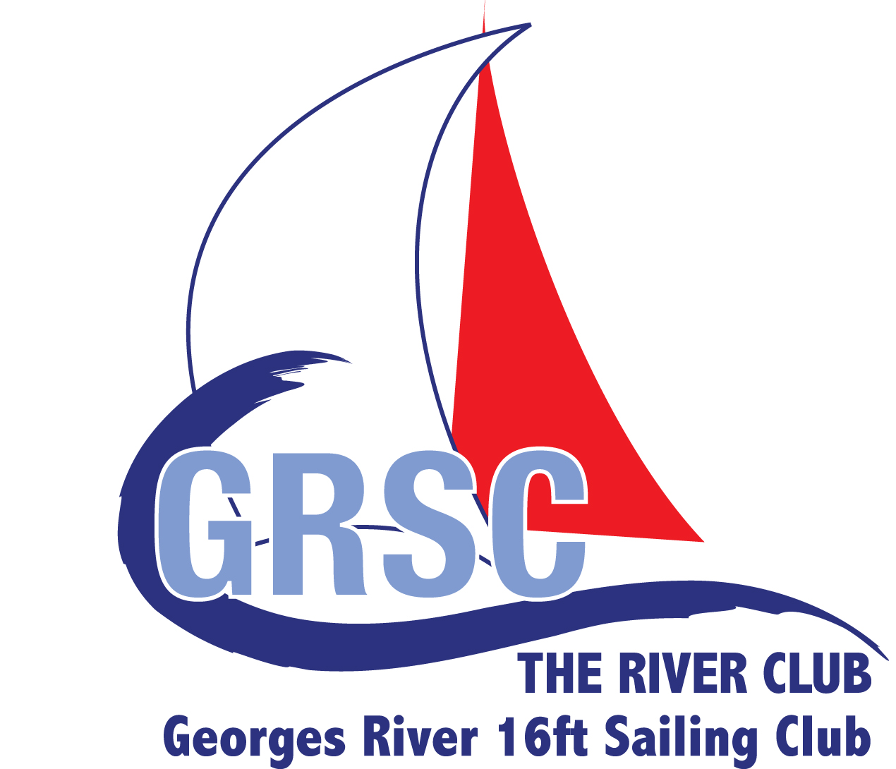

The Organising Authority for this regatta is Georges River 16 ft Sailing Club Co-op (GR16ftSC) in conjunction with the NSW and ACT District Laser Association Inc. and the Australian Laser Class Association Inc. (ALCA). The Organising Authority invites entries for the 2011 Australian Laser Championships to be conducted on Botany Bay, NSW from the 27th of December 2010 to the 4th January 2011.

- RULES:
- The Championships will be governed by the rules as defined in the Racing Rules of Sailing 2009-2012, the Rules and By-laws of the International Laser Class Association (except as these may be changed by the Sailing Instructions) and by the Sailing Instructions.
- Yachting Australia Special Regulations Part 2 Off the Beach Boats will apply. It will be the responsibility of all competitors to ensure that personal flotation devices comply with a standard equivalent to those listed in Regulation 5.01 Personal Flotation Devices.
- Sails shall have the full sail number in accordance with the Class Rules and RRS.

- ADVERTISING
- The Organizing Authority reserves the right to refuse advertising by any boat, if it is considered offensive to public taste or if it contravenes the laws of the governments of NSW or Australia.
Competitors may be required to display event sponsor’s names(s)/logo(s) and affix bow numbers to boats. If required, the Organizing Authority will supply these items and they shall be affixed as prescribed in the Sailing Instructions. Sponsor’s bibs or similar may also be supplied.

- ELIGIBILITY

- All competitors shall be financial members of a District of the International Laser Class Association (ILCA) and of a yacht or sailing club affiliated with ISAF.
- Proof of age shall be required for entrants in any of the age-related divisions.
- Eligibility for age group divisions in any of the Youth divisions shall be the competitor’s age as at 31st December 2011. Under 16 is defined as being under 16 years of age at 31st December 2011, Under 17 is defined as being under 17 years of age at 31st December 2011, Under 19 is defined as being under 19 years of age at 31st December 2011 and Under 21 is defined as being under 21 years of age at 31st December 2011.
- All competitors shall have adequate and current Public Liability insurance covering the use of the boat while racing (See Clause 19a).

4. ENTRIES
- Entries may be lodged online via the Regatta web site at http://www.laser.asn.au or by mail to NSW and ACT District Laser Association at PO Box K315, Haymarket NSW 2000 before 1700hrs (ESDST) on 1st December 2010 accompanied by the required entry fee (see Clause 5).
- Late entries will be accepted via the Regatta web site up to 1300 hours 26th December 2010 accompanied by the required Entry Fee plus the Late Fee.
- At the discretion of the Organizing Authority, late entries may be accepted (in person only) at the Regatta Office, GR16ftSC between 0900 hrs and 1430 hrs on 27th December 2010
- All boats shall complete registration with the Organizing Authority at the times specified in Clause 7.
- The Organizing Authority will not refund Entry or Late Fees in any circumstances. Entries will not be valid until applicable payment has been received by the Organizing Authority.
5. FEES
- The Entry Fee for all classes and divisions (which includes one ticket to the Welcome function and one ticket to 2 casual dinners during the regatta) is $250.00.
- The Late Fee is an additional $100.00 with no exceptions.

6. CLASSES, DIVISIONS AND RACING FORMAT

- Racing will be conducted in three (3) Classes as follows:
  - Laser Standard
  - Laser Radial and
  - Laser 4.7
- Divisions will include:
  - Under 21 within the Standard Class
  - Women, Under 17 and Under 19 within the Radial Class
  - Women and Under 16 within the 4.7 Class
provided a minimum of 5 entries are received for that Division.
- Fleets within each Class shall be that combination of boats as nominated by the Organizing Authority.
- Depending on the number of entries Classes may be sailed as (i) a normal series or (ii) a qualifying and final series.
- For a qualifying and final series format, competitors will sail 4 days (29th December 2010 to 2nd January 2011) of qualifying races and 2 days (3rd and 4th January 2011) of finals races.
- Depending on fleet numbers the Organizing Authority may require fleets to race each day in 2 separate colour groups. These groups will be changed for each day of Qualifying races. After completion of the Qualifying races, the fleets will be seeded into Gold and Silver Fleets. Seeding for Gold and Silver fleets will be based on standings after discard (if any) at the conclusion of racing on 2nd January 2011. Any discard shall be a boat’s worst excludable score.

7. PROGRAM

- Schedule of Events:

Monday 27th Dec 2010 Registration and Measurement 0800 – 1700
Welcome Function 1900
Tuesday 28th Dec 2010 Competitors Meeting 1100
Practice Race 1st Warning Signal 1330
Wednesday 29th Dec 2010 Races 1, 2 1st Warning Signal 1330

Thursday 30th Dec 2010 ALCA Annual General Meeting 0930
Races 3, 4 1st Warning Signal 1330
Friday 31st Dec 2010 Races 5, 6 1st Warning Signal 1330

Saturday 1st Jan 2011 Lay-day

Sunday 2nd Jan 2011 Races 7, 8 1st Warning Signal 1330

Monday 3rd Jan 2011 Races 9, 10 1st Warning Signal 1330

Tuesday 4th Jan 2011 Races 11, 12 1st Warning Signal 1030
Presentation 1700 approx

- Two races per day are planned. Additional races may be sailed on any day provided that no fleet becomes more than one race ahead of schedule.
- The Race Committee may elect to change the start time of the following day’s racing based on weather forecasts and the various fleet requirements. A notice advising of any such change will be posted no later than 1830 on the preceding race day.

8. MEASUREMENT
- All boats and equipment shall be presented to the official measurers for scrutiny and approval during the times specified in clause 7(a)
- As beach trailers/dollys will be shared during the regatta, all boats shall be presented for Measurement on serviceable beach dollys. ‘Serviceable’ specifically includes being fitted with pneumatic tyres at least 6cm wide (launch/retrieval at GR16ftSC is over soft beach sand) and have adequate padding. Any boat presented on an unsatisfactory or unserviceable beach trailer/dolly will be refused entry at Measurement.
- For the duration of the regatta, each competitor shall use only one hull, sail, mast, boom,
centreboard and rudder, each of which shall be identified and stamped or otherwise marked by the official measurer during measurement. Such equipment may only be replaced as allowed by and in accordance with the Sailing Instructions.
- The boats of female competitors shall display a red diamond on their sail in accordance with ILCA Women’s Policy.

9. SAILING INSTRUCTIONS

Sailing Instructions will be available when registering at the Regatta Office at GR16ftSC and may be available earlier on the Regatta website at http://www.laser.asn.au

10. REGATTA SITE AND RACING AREA

The regatta site shall be Georges River 16ft Sailing Club (Sanoni Ave, Dolls Point, Sydney NSW) and the racing area shall be on the open waters of Botany Bay in the vicinity of the club.

11. COURSES

The courses shall be trapezoidal type, as described in the Sailing Instructions.

12. PENALTY SYSTEM

- Appendix P as modified by the Sailing Instructions shall apply.
- Application for the appointment of a National Jury has been made.
The right of appeal shall be denied in accordance with rule 70.5 and the National prescriptions thereto.

13. MEDIATION

- Mediation may be used for potential breaches of rules of RRS part 2.
- Through mediation a boat may take a scoring penalty of 20% of the fleet size in that race.

14. SCORING
- Fleets with a Normal series
Twelve (12) races are scheduled. Six (6) races are required to constitute a series with the following discard provisions:

Races Completed Discards
up to 6 0
7 - 10 1
11-12 2
- Fleets with a Qualifying and Finals series
Twelve (12) races are scheduled. 8 races are planned for the Qualifying series and 4 races for the Final series. A qualifying race will not count until both qualifying races for that fleet for that race have been completed. A total of six (6) races are required to constitute a series with the following discard provisions:

Qualifying Races Races Completed Discards
up to 5 0
6 - 8 1
Final Races Races Completed Discards
1 - 2 0
3 - 4 1

- When a Class sails a Qualifying and Finals series, the Gold and Silver Fleets (as determined at Clause 6f) will be scored separately based on the sum of each boat’s scores (after discards) in both qualifying and final races.
- Except as modified by the Sailing Instructions, all Division prizes will be awarded based on the ranking of competitors in the overall results of the applicable Class.

15. SUPPORT BOATS

- Team leaders, coaches, and other support personnel shall not be in the racing area, which is defined as within 100 metres of a competitor or a mark of the course. This will apply from the time of the Preparatory Signal for the first fleet to start until all boats have finished that race or the Race Committee signals a postponement, general recall or abandonment – except in the case of an emergency when asked to assist by the Race Officer. The penalty for failing to comply with this requirement may be disqualification (after protest) of all boats associated with the support personnel who infringe.
- All support boats shall register at the Regatta Office as set out in clause 7 and display a numbered flag (supplied by the Organizing Authority).
- Please note – there are no moorings for coach or support boats at GR18ftSC. All coaches/support personnel are advised to make arrangements to retrieve their boats at the end of each day’s racing.

16. RADIO COMMUNICATIONS

A boat shall neither make radio transmissions while racing nor receive radio
communications not available to all boats. This also applies to the use of mobile phones or similar devices.

17. PRIZES

- Laser Class cubes and other prizes shall be awarded in accordance with ILCA guidelines; therefore the number of prizes allocated in any division shall depend on the number of entries. A minimum of five (5) entries is required to constitute a Division.
- Only Australian residents shall be eligible for Laser Class cubes and perpetual trophies. A resident of Australia is one who is a member of a District of the ALCA, a member of a yacht or sailing club affiliated with Yachting Australia and who reasonably satisfies the Organising authority of long-term (at least one year’s) residency.
- Medallions will be awarded to all place-getters regardless of nationality, based on normal ILCA fleet-size guidelines.
- Perpetual Trophies will be awarded in accordance with ALCA policy.
- Other prizes may be awarded at the discretion of the Organizing Authority.

18. DISCLAIMER OF LIABILITY

Competitors participate in the regatta entirely at their own risk – see RRS 4, Decision to Race. None of the Organizing Authority, the NSW & ACT District Laser Association, ALCA or GR16ftSC will accept any liability for material damage or personal injury or death sustained in conjunction with, prior to, during or after the regatta.

19. INSURANCE

All competitors must have a valid Third Party Insurance Policy with a minimum cover of
AUD $10,000,000 whilst racing. Signing the Entry and Declaration Form confirms currency of this insurance.

20. RIGHTS TO USE NAME AND LIKENESS

- In signing the Entry Form and participating in the regatta a competitor automatically grants the Organizing Authority and the sponsors of the regatta the right in perpetuity to make, use and show, from time to time and at their discretion, any motion pictures, still pictures and live, taped or film television and other reproductions of him/her during the period of the competition for the said regatta in which the competitor participates and in all material related to the said regatta without compensation.

21. CHANGES TO NOTICE OF RACE

Any changes to this Notice of Race will be published on the regatta web site http://www.laser.asn.au no later than 30th November 2010.

22. FURTHER INFORMATION

For further information, please contact Kath Herrmann regattasec@laser.asn.au

23. CHARTER BOATS

Charter boats will not be provided by the Organizing Authority, but may be available from a range of independent providers. Further information may be obtained from the event web site http://www.laser.asn.au or from
Performance Sailcraft Australasia +61 2 4389 1088
  - Michael Mills
  - Jason Goulding
  - Website
NB Laser Hobie Sports +61 2 4321 1320
i Kevin Winchester +61 412 464 283
ii Sales Team +61 412 485 216
iii Website

