NOTICE OF RACE

2010 Australian University Fleet Racing Regatta

Thursday 8th to Saturday 10th of April 2010
Great Lakes Sailing Club
Forster, NSW

1 Organising Authority and Venue
The organising authority Great Lakes Sailing Club (GLSC) hosted by Sydney Uni Sailing Club. The venue for the regatta is Great Lakes Sailing Club, The Lakes Way, Forster. Directions and location map are shown in Appendix A.

- Rules
The regatta will be governed by:
- The rules as defined by The Racing Rules of Sailing (RRS) 2009-2012,
- Yachting Australia Inc. (YA) Special Regulations - Part 2 (off the beach classes),
- The Notice of Race and Sailing Instructions (SIs) and,
- Australian University Sailing – Fleet Racing Championship Rules.

3 Alterations of Racing Rules
The racing rules will be modified in accordance with rule 86 as follows:

Rule 44.1, taking a Penalty is altered to read: “A boat that may have broken a rule of part 2 while racing may take a penalty at the time of her incident. Her penalty shall be a 360° Turn Penalty”.

4 Eligibility and Entry

  - The regatta is open to all university attendees and open to all classes of boats including sailboards. A Boats handicap will be determined by the VYC yard stick system for the purpose of scoring.

  - Eligible sailors can enter on the attached Entry Form which shall be lodged with:

Entries must be received by 1100hrs on 8th of April 2009 at Great Lakes Sailing Club and
must be accompanied by the required fee.

- Fees and Registration
Entry fees include welcome BBQ on Thursday evening and a regatta entry pack with merchandise.

Register before March 31 by completing the online entry form:
https://spreadsheets.google.com/viewform?formkey=dHNYLTNsdmJ4aWdMVWNWZHdBa2RxOUE6MA

Regatta entry fee for forms received by March 31 is $50 per person. Late entries will be received until 1100 hours on the April 8, but an additional late entry fee of $10 per person will apply to entries submitted after March 31.

Note: the online entry form does not include payment. All payments are to be made in cash on April 8 at GLSC.

6 Insurance
All boats must carry third party insurance cover of at least AUD$5,000,000. For clarification about insurance policies please contact the event organisers.
7 Schedule of Events

  - Registration:
8th of April from 0800hrs to 1100hrs

Briefing
8th of April at 1200hrs

Day & Date | Number of Races | Time of racing and social events
Thursday 8th of April | Maximum 3 Races | Racing not before 1300hrs  No race start after 1700hrs  Welcome BBQ ASAP after racing
Friday 9th of April | Maximum 3 Races | Racing not before 1200hrs  Regatta party (theme TBA) 1730hrs
Saturday 10th of April | Maximum 3 Races | 1200hrs  No race start after 1600hrs  Prize giving ASAP after racing.

8 Measurements
It is the responsibility of the boats skipper to ensure that each boat complies with its relevant classes
measurement rules.

9 Sailing Instructions
The sailing instructions (SIs) will be available during registration at Great Lakes Sailing Club from 8am on Thursday April 8, 2010. If possible, SIs will be distributed via e-mail to all entrants received before April 1, 2010.

10 Racing Area
The racing area shall be on the waters of Wallis Lake, accessed via Great Lakes Sailing Club which is located in Booti Booti National Park. Directions and location map are shown in Appendix A.

11 Courses
The courses will be prescribed in the sailing instructions and at the race briefing.

12 Scoring
The low point scoring system, Appendix A.4.1 will apply. An overall team championship trophy will be also determined and awarded.

13 Prizes
Prizes will be awarded at the discretion of the organising committee and in accordance with the final
results provided by the race committee.

14 Further Information

Camping is available at the club for a cost of $5 per night, payable on arrival. There is also a parking fee of $10 per car (covers the whole weekend).

100% of camping and parking fees are collected on behalf of, and forwarded directly to National Parks and Wildlife Service (NPWS). You are not required to pre-book camping sites.

Alternative accommodation can be arranged by contacting Great Lakes Visitor Tourism:
02 6554 8799
tourism@greatlakes.nsw.gov.au
www.greatlakes.org.au/
The closest non-camping accommodation options (approx 3km from GLSC) are Green Point or Tiona Caravan Park.

For further information, please contact:
Tom Mallet Kingsley Pursch
usydsailing@gmail.com kapur1@student.monash.edu
0416 308 818 0421 995 281

Appendix A – Directions and Location Map

Heading North From Sydney (approx 3.5 hours from Syd), you have two options. Timing is similar. Option 1 is shorter distance but a slower, winding road. Option 2 sticks on the highway but covers more distance. Many people towing boats prefer option 2, especially if travelling at night.
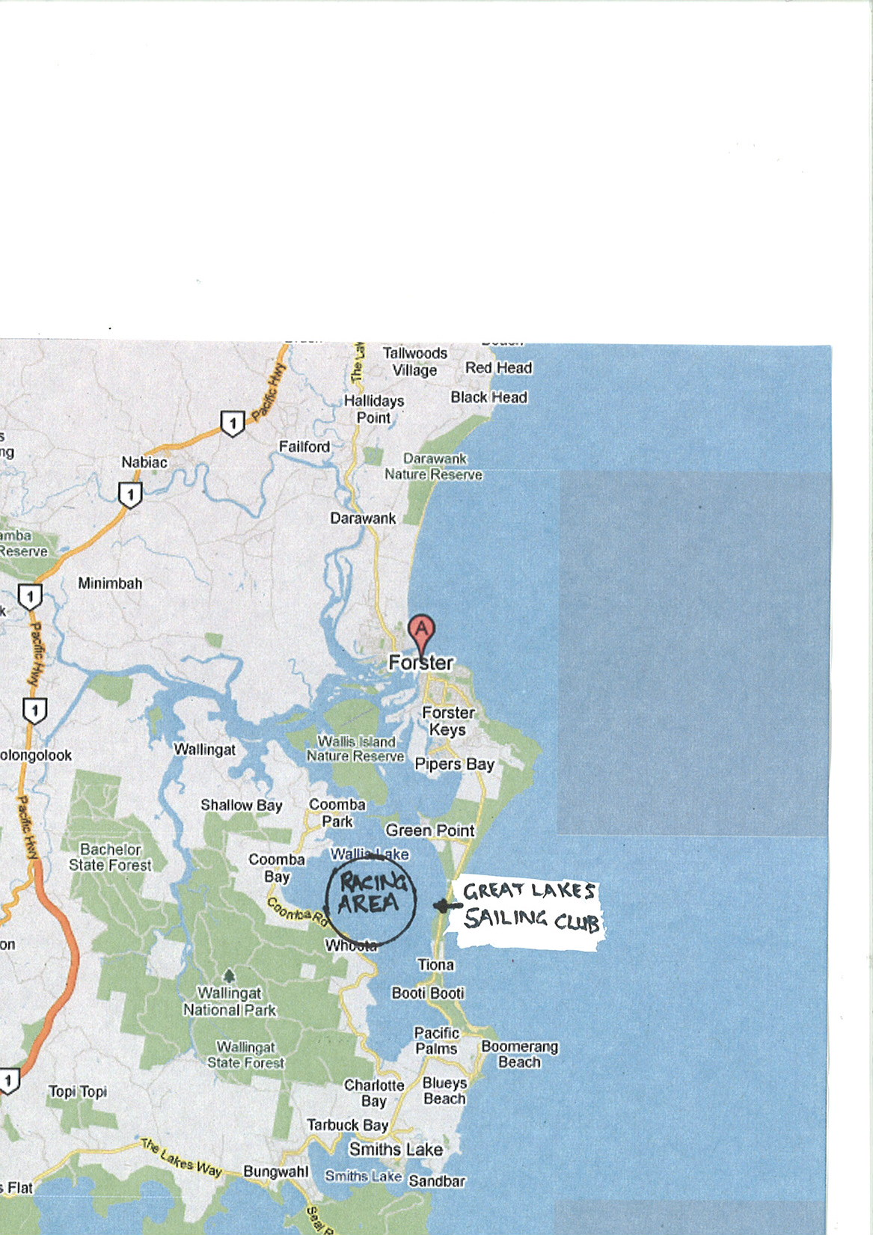
- Near Buladelah turn onto the Lakes Way and head North, winding past Smiths Lake on your right and through the townships of Bungwahl, Tarbuck Bay and Charlotte Bay. Continue past the Pacific Palms Rec Club. Continue past Sundowner Tiona Caravan Park. The turnoff to GLSC is on your left approximately 3km past Tiona Caravan Park.
- Follow the Pacific Highway through Coolongolook and Nabiac. Approximately 4km past Nabiac turn right onto Failford Road (keep an eye out because it sneaks up on you). Follow Failford road for 5-10km until you hit a T-intersection. Turn right here onto The Lakes Way. Follow South through Tuncurry, over the bridge, and through Forster towards Pacific Palms. Now follow “From Forster” directions below.
From Forster - follow the Lakes Way south past Forster High School and through a 100km/hr zone that includes Booti Booti National Park. Continue along the Lakes Way past the Green Point turnoff on your right. The turnoff to GLSC is approximately 3km past the Green Point turnoff, and 200 metres after Camp Elim turnoff.
Heading South from Brisbane (approx 8 hours) – Travelling South along the Pacific, take the first exit onto The Lakes Way. Follow this road through Tuncurry and Forster, and continue along The Lakes Way following “From Forster” directions above.

