2010 – 2011
LASER, LASER RADIAL AND LASER 4.7
NSW STATE CHAMPIONSHIP
and
NSW STATE MASTERS CHAMPIONSHIP
13th and 14th November 2010
Georges River 16 Foot Sailing Club
NOTICE OF RACE

The Organising Authority is the NSW & ACT District Laser Association in association with Georges River 18ft Sailing Club under the authority of Yachting NSW
- RULES
The Championship will be governed by the 2009-2012 Racing Rules of Sailing, the Prescriptions and Special Regulations of Yachting Australia, the rules and by-laws of the International Laser Class Association, (except as any of these are changed by the Sailing Instructions) and by the Sailing Instructions.
- ELIGIBILITY
All competitors shall be financial members of a District of the ILCA and of a Yacht or Sailing Club affiliated with a National Authority. Eligibility for age groups shall be the age on 13 November 2010.
- ENTRIES
  - Entries on the attached entry form, or on-line at www.laser.asn.au, together with the entry fee should reach the Regatta Secretary by the close of official entries on 6 November 2010.
  - Late entries may be accepted up until 1130 hours Saturday 13 November 2010.
- FEES
Entry fee schedule:
- $60.00 per boat
- $70.00 after close of official entries

- SCHEDULE
  - Championship Schedule:
Day | Date | Event | Time
Sat | 13 Nov | Registration | 0930 – 1130 hrs
Sat | 13 Nov | Briefing | 1130 hrs
Sat | 13 Nov | Racing | First Warning Signal 1330 hrs. Subsequent starts shall be made ASAP after the preceding race
Sun | 14 Nov | Racing | First Warning Signal 1100 hrs. Subsequent starts shall be made ASAP after the preceding race
  - A maximum of six races are scheduled for the Championship.
  - No Warning Signal shall be hoisted after 1530 hrs on the Sunday 14 November 2010.
- MEASUREMENT
Each skipper shall be responsible for ensuring that their yacht and equipment comply with the ILCA rules and the Yachting Australia Special Regulations. The Organising Authority reserves the right to inspect any yacht at any time during the Regatta.
- SAILING INSTRUCTIONS
The Sailing Instructions should be available on the NSW and ACT Laser Association website http://www.laser.asn.au/ from 8 November 2010 and will be available at registration.
- REGATTA SITE
The Championship venue is shown in Illustration A. Georges River 16 Foot Sailing Club (GR16’SC) is located on Sanoni Avenue, Dolls Point, Sydney www.georgesriversailingclub.com.au
- RACING AREA
The racing area will be on the waters of Botany Bay.
- CATEGORIES AND DIVISIONS
Categories are as described in the Entry Form. The Masters’ Divisions shall start separately from the
Open Divisions, except that the Apprentice Master Radial Division shall start with the Open Radial Division and the Apprentice Master Standard Division shall start with the Open Standard Division. For this regatta GGM may sail in the Standard Division and will be awarded prizes and Laser cubes subject to normal ILCA guidelines.
- COURSES
The courses shall be inner and outer loop trapezoids as described in the Sailing Instructions.
- SCORING
Six races are scheduled, of which three shall be completed to constitute a series. When four or more races are completed, the worst will be discarded. All Divisions will be scored separately.
- PRIZES
Cubes will be awarded in accordance with the ILCA By-Laws. Other prizes may also be awarded at the discretion of the organisers.
- INSURANCE
Each participating boat shall be insured with a valid third party liability insurance with cover of not less than $AUS 10,000,000.
- DISCLAIMER
All those taking part in this Regatta do so at their own risk and responsibility. Attention is drawn to RRS Fundamental Rule 4 Decision to Race “A boat is solely responsible for deciding whether or not to start or to continue racing”. Yachting NSW, the NSW and ACT District Laser Association, GR16’SC, their officers, and the Regatta officials, volunteers and sponsors do not accept any liability for the material damage or personal injury or death sustained in conjunction with or prior, during or after the regatta. GR16’SC and/or the NSW and ACT District Laser Association reserve the right to refuse an entry.
NSW & ACT DISTRICT LASER ASSOCIATION
2010-2011 STATE CHAMPIONSHIP
and STATE MASTERS CHAMPIONSHIP

ENTRY FORM
(please print clearly in Block Letters)
Sail No. ________________________________________
Skipper ____________________________________
Club ___________________________________________
Skipper’s Age _______(For Championship. See NoR 2)
Divisions / Categories (please circle applicable category):

STANDARD | RADIAL | 4.7
Open | Open | Open
U21 | U19
Apprentice | Apprentice
Master | Master
Grand Master | Grand Master
Great Grand Master | Great Grand Master
 | Women

Address ________________________________________
_______________________________________________
Phone __________________ (w)___________________(h)
Mob __________________email _____________________
I agree to be bound by The Racing Rules of Sailing and all other rules that govern this event
Signed ______________________________Date______________
For sailors under 18 on 13 November 10, parent of guardian to
sign below:
Parent or Guardian ____________________Date _____________
Please return, with appropriate fee by 2359hr 6 November 2010 to:
Regatta Secretary NSW & ACT District Laser Association
PO Box K315
Haymarket, Sydney NSW 2000

Entry Fees:
$60.00
Late entry fee payable after close of official entries:
$70.00
To pay Entry Fee by credit card
VISA Mastercard Bankcard
Card No __ __ __ __ __ __ __ __ __ __ __ __ __ __ __ __
Expiry date __ __/ __ __ Amount $_____________
Name of Card Holder ______________________________
Card Holder signature_______________________________
If paying by Cheque, please make cheque payable to:
’NSW & ACT District Laser Association’
Entries can be made on line, go to www.laser.asn.au and follow the link for on-line entry and payment.

Illustration A : Regatta Site

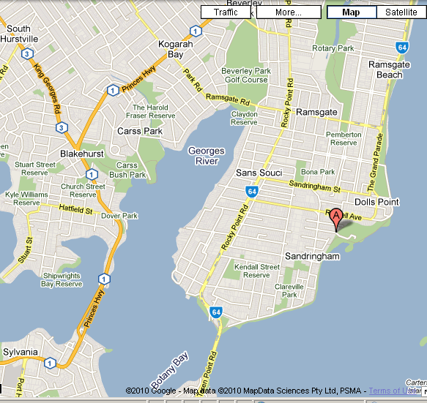

NSW & ACT DISTRICT
LASER ASSOCIATION

2010 - 2011

LASER, LASER RADIAL AND LASER 4.7
NSW STATE CHAMPIONSHIP
and
NSW STATE MASTERS CHAMPIONSHIP

NOTICE OF RACE

13th and 14th November 2010

Hosted by

Georges River 16ft Sailing Club

Organising Authority

NSW and ACT District Laser Association
In association with
Georges River 16ft Sailing Club
under the authority of
Yachting NSW

