2010 – 2011
NSW AND ACT DISTRICT LASER ASSOCIATION
LASER, LASER RADIAL AND LASER 4.7
NSW COASTS CHAMPIONSHIP
16th and 17th October 2010
South Lake Macquarie Amateur Sailing Club
NOTICE OF RACE

The Organising Authority is the NSW & ACT District Laser Association under the authority of Yachting NSW
1. RULES
The Championship will be governed by the 2009-2012 Racing Rules of Sailing, the Prescriptions and Special Regulations of Yachting Australia, the rules and by-laws of the International Laser Class Association, (except as any of these are changed by the Sailing Instructions) and by the Sailing Instructions.
2. ELIGIBILITY
All competitors shall be financial members of a District of the ILCA and of a Yacht or Sailing Club affiliated with a National Authority. Eligibility for age groups shall be the age on 16 October 2010.
3. ENTRIES
3.1 Entries on the attached entry form, or on-line at www.laser.asn.au, together with the entry fee should reach the Regatta Secretary by the close of official entries on 10 Oct 2010.
3.2 Late entries may be accepted up until 1130 hours Saturday 16 October 2010.
4. FEES
Entry fee schedule:
- $60.00 per boat
- $70.00 after close of official entries

5. SCHEDULE
5.1 Championship Schedule:
Day | Date | Event | Time
Sat | 16 Oct | Registration | 0930 – 1130 hrs
Sat | 16 Oct | Briefing | 1130 hrs
Sat | 16 Oct | Racing | First Warning Signal 1330 hrs. Subsequent starts shall be made ASAP after the preceding race
Sun | 17 Oct | Racing | First Warning Signal 1100 hrs. Subsequent starts shall be made ASAP after the preceding race
  - A maximum of six races are scheduled for the Championship.
  - No Warning Signal shall be hoisted after 1530 hrs on Sunday 17 October 2010.
6. MEASUREMENT
Each skipper shall be responsible for ensuring that their yacht and equipment comply with the ILCA rules and the Yachting Australia Special Regulations. The Organising Authority reserves the right to inspect any yacht at any time during the Regatta.
7. SAILING INSTRUCTIONS
The Sailing Instructions will be available on the NSW and ACT Laser Association website (http://www.laser.asn.au/) from 11 October 2010 and at registration.
8. REGATTA SITE
The Championship venue is shown in Illustration A. South Lake Macquarie Amateur Sailing Club is located on Sunshine Parade, Morisset, NSW http://www.slmasc.ourclub.info/
9. RACING AREA
The racing area will be on the waters of south Lake Macquarie.

10. DIVISIONS
Divisions are as described in the Entry Form.
11. COURSES
The courses shall be inner and outer loop trapezoids as described in the Sailing Instructions.
12. SCORING
Six races are scheduled, of which three shall be completed to constitute a series. When four or more races are completed, the worst will be discarded. All Divisions will be scored separately.
13. PRIZES
Prizes will be awarded to the Winners of each Division. Other prizes may also be awarded at the discretion of the organisers.
14. INSURANCE
Each participating boat shall be insured with a valid third party liability insurance with cover of not less than $AUS 10,000,000.

NSW & ACT DISTRICT LASER ASSOCIATION
2010-2011 COASTS CHAMPIONSHIP

ENTRY FORM
(please print clearly in Block Letters)
Sail No. ________________________________________
Skipper ____________________________________
Club ___________________________________________
Skipper’s Age _______(For Championship. See NoR 2)
Divisions / Categories (please circle applicable category):

STANDARD | RADIAL | 4.7
Open | Open | Open
U 21 | U 19
Apprentice | Apprentice
Master | Master
Grand Master | Grand Master
 | Great Grand Master
 | Women’s

Address ________________________________________
_______________________________________________
Phone __________________ (w)___________________(h)
Mob __________________email _____________________
I agree to be bound by The Racing Rules of Sailing and all other rules that govern this event
Signed ______________________________Date______________
For sailors under 18 on 16 Oct 10, parent of guardian to
sign below:
Parent or Guardian ____________________Date _____________
Please return, with appropriate fee by 16 Oct 10 to:
Regatta Secretary NSW & ACT District Laser Association
PO Box K315
Haymarket, Sydney NSW 2000

Entry Fees:
$60.00
Late entry fee payable after close of official entries:
$70.00
To pay Entry Fee by credit card
VISA Mastercard Bankcard
Card No __ __ __ __ __ __ __ __ __ __ __ __ __ __ __ __
Expiry date __ __/ __ __ Amount $_____________
Name of Card Holder ______________________________
Card Holder signature_______________________________
If paying by Cheque, please make cheque payable to:
’NSW & ACT District Laser Association’
Entries can be made on line, click here

Illustration A : Regatta Site

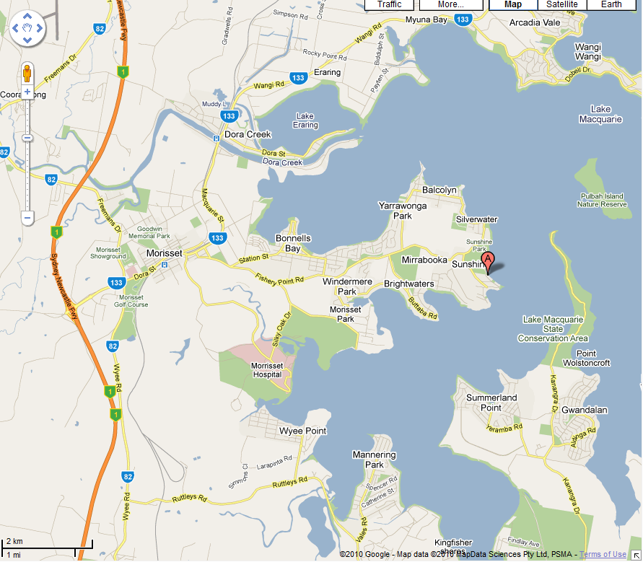
Mandalong Road
SLMASC

NSW & ACT DISTRICT
LASER ASSOCIATION

2010 - 2011

LASER, LASER RADIAL AND LASER 4.7
COASTS CHAMPIONSHIP

NOTICE OF RACE

16th and 17th October 2010

Hosted by

South Lake Macquarie Amateur Sailing Club

Organising Authority

NSW and ACT District Laser Association
under the authority of
Yachting NSW

