2009 – 2010
NSW AND ACT DISTRICT LASER ASSOCIATION
LASER, LASER RADIAL AND LASER 4.7
NSW MASTERS CHAMPIONSHIP
(ROUND 2 OF THE
PSA MASTERS CHAMPIONSHIP)
14th and 15th November 2009
Great Lakes Sailing Club
NOTICE OF RACE

(Amendment One)

The Organising Authority is the NSW & ACT District Laser Association under the authority of Yachting NSW
1. RULES
The Championship will be governed by the 2009-2012 Racing Rules of Sailing, the Prescriptions and Special Regulations of Yachting Australia, the rules and by-laws of the International Laser Class Association, (except as any of these are changed by the Sailing Instructions) and by the Sailing Instructions.
2. ELIGIBILITY
All competitors shall be financial members of a District of the ILCA and of a Yacht or Sailing Club affiliated with a National Authority. Eligibility for age groups shall be the age on 14 November 2009.
3. ENTRIES
3.1 Entries on the attached entry form, or on-line at www.laser.asn.au, together with the entry fee should reach the Regatta Secretary by the close of official entries on 8 November 2009.
3.2 Late entries may be accepted up until 1130 hours Saturday 14 November 2009.

4. FEES
Entry fee schedule:
- $60.00 per boat
- $70.00 after close of official entries
5. SCHEDULE
5.1 Championship Schedule:
Day | Date | Event | Time
Sat | 14 Nov | Registration | 0930 – 1130 hrs
Sat | 14 Nov | Briefing | 1130 hrs
Sat | 14 Nov | Racing | First Warning Signal 1330 hrs. Subsequent starts shall be made ASAP after the preceding race
Sun | 25 Nov | Racing | First Warning Signal 1100 hrs. Subsequent starts shall be made ASAP after the preceding race
  - A maximum of six races are scheduled for the Championship.
  - No Warning Signal shall be hoisted after 1530 hrs on the Sunday .
6. MEASUREMENT
Each skipper shall be responsible for ensuring that their yacht and equipment comply with the ILCA rules and the Yachting Australia Special Regulations. The Organising Authority reserves the right to inspect any yacht at any time during the Regatta.
7. SAILING INSTRUCTIONS
The Sailing Instructions will be available on the NSW and ACT Laser Association website www.laser.asn.au from 9 November 2009 and at registration.
8. REGATTA SITE
The Championship venue is shown in Illustration A. Great Lakes Sailing Club is located on The Lakes Way, Booti Booti, Forster, NSW.

9. RACING AREA
The racing area will be on the waters of Wallis Lake.
10. DIVISIONS
Divisions are as described in the Entry Form.
11. COURSES
The courses shall be inner and outer loop trapezoids as described in the Sailing Instructions.
12. SCORING
Six races are scheduled, of which three shall be completed to constitute a series. When four or more races are completed, the worst will be discarded. All Divisions will be scored separately.
13. PRIZES
Prizes will be awarded to the Winners of each Division. Cubes will be awarded according to ILCA
By-Laws. The divisions are set out in the entry form. Other prizes may also be awarded at the discretion of the organisers.
14. INSURANCE
Each participating boat shall be insured with a valid third party liability insurance with cover of not less than $AUS 10,000,000.

NSW & ACT DISTRICT LASER ASSOCIATION
2009-2010 MASTERS CHAMPIONSHIP
(ROUND 2 OF THE PSA MASTERS CHAMPIONSHIP)
ENTRY FORM
(please print clearly in Block Letters)
Sail No. ________________________________________
Skipper ____________________________________
Club ___________________________________________
Skipper’s Age _______(For Championship. See NoR 2)
Divisions / Categories (please circle applicable category):

STANDARD | RADIAL | 4.7
Apprentice | Apprentice | Open
Master | Master
Grand Master | Grand Master
 | Great Grand Master
 | Women

Address ________________________________________
_______________________________________________
Phone __________________ (w)___________________(h)
Mob __________________email _____________________
I agree to be bound by The Racing Rules of Sailing and all other rules that govern this event
Signed ______________________________Date______________
Please return, with appropriate fee by 8 Nov 09 to:
Regatta Secretary NSW & ACT District Laser Association
PO Box K315
Haymarket, Sydney NSW 2000

Entry Fees:
$60.00
Late entry fee payable after close of official entries:
$70.00
To pay Entry Fee by credit card
VISA Mastercard Bankcard
Card No __ __ __ __ __ __ __ __ __ __ __ __ __ __ __ __
Expiry date __ __/ __ __ Amount $_____________
Name of Card Holder ______________________________
Card Holder signature_______________________________
If paying by Cheque, please make cheque payable to:
’NSW & ACT District Laser Association’
Entries can be made on line, go to www.laser.asn.au and follow the link for on-line entry and payment.

Illustration A : Regatta Site

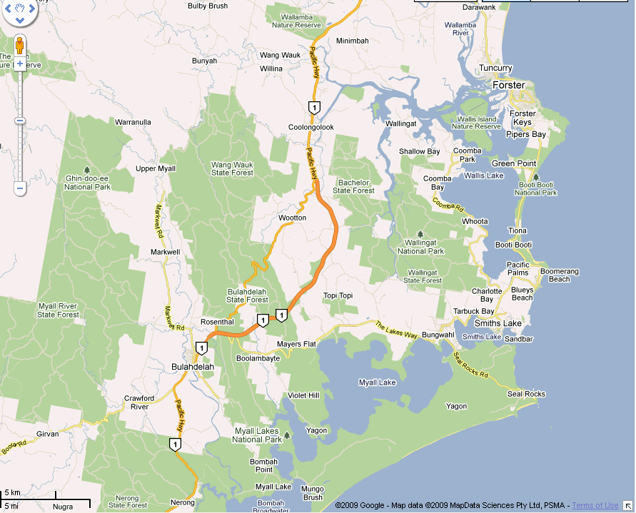

NSW & ACT DISTRICT
LASER ASSOCIATION

2009 - 2010

LASER, LASER RADIAL AND LASER 4.7
MASTERS CHAMPIONSHIP
(ROUND 2 OF THE PSA MASTERS CHAMPIONSHIP)

NOTICE OF RACE
(Amendment One)
14th and 15th November 2009

Hosted by

Great Lakes Sailing Club

Organising Authority

NSW and ACT District Laser Association
under the authority of
Yachting NSW

